**COST ANALYSIS**

What is cost analysis?

Ans: Cost analysis of a project is basically stands for the act of breaking down a cost summary into its constituents and studying and reporting on each factor. The actual purpose of the comparison of costs for disclosing and reporting on conditions subject to improvement of the project.

The information obtained during a cost-benefit analysis makes budgeting easier. If all the possible costs listed, one can project the budget needed to undertake the project. The anticipated benefits can also be used to project sales if they can be quantified into financial goals. Both of these considerations are useful when preparing budgets and sales projections.

Project description: Our project is basically based on creating a website for fresh food ordering. To startup our project we need some basic equipment. Like:

An office that is must to work together and also some furniture’s to setup the look of the office. A Caretaker who will look after the office, materials and so on.

Website customized with unique logo which is free of cost, attractive color theme and beautiful images, simple CMS, eye catching slider, easy navigations, pleasing UI/UX, Gallery, Responsive web design and payment method . Free domain/hosting is for 6 months. It is 2500 TK/year after that. Free two months webpage maintenance. After two month, the client must pay 30,000 per month.

The chart of Cost analysis for our required things to start our project is given below:

|  |  |  |  |  |
| --- | --- | --- | --- | --- |
| Work Description | Quantity | Month | Cost(per month) | Total Cost(Taka) |
| Office and Administration Expenses : |  |  |  |  |
| 1.Office rent |  | 4 | 12000 | 48000 |
| 2.Furniture |  |  | 20000 | 20000 |
| 3.Computer | 6 |  |  | 250000 |
| 4. Caretaker | 1 | 4 | 5000 | 20000 |
| 5.Host cost | 1 | 4 | 5000 | 20000 |
| Billing cost : |  |  |  |  |
| 1.Telephone | 7 | 4 | 700 | 2800 |
| 2 Internet |  | 4 | 1000 | 4000 |
| 3.Utilities |  | 4 | 6000 | 24000 |
| Developing Cost: |  |  |  |  |
| 1.Dynamic Pages | 15 |  |  | 15,000 |
| 2. CMS | 1 |  |  | 5,000 |
| 3. SEO friendly | 1 |  |  | 5,000 |
| 4. Responsive Design |  |  |  | 8,000 |
| 5. Payment Getway |  |  |  | 15,000 |
| Total |  |  |  | 2,11,800 |

**Pie Chart:**

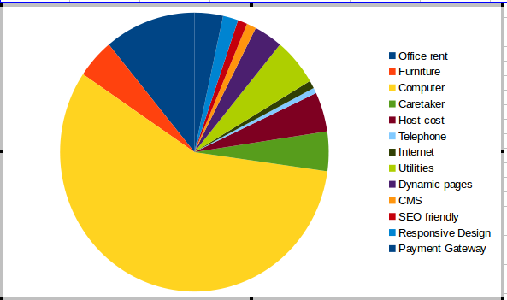

**Figure: Pie Chart of cost analysis**